SQL Select

🌟 Definition
# Source: AI Source: Provided by: [Data Path: Persons Table -> ID Column: 1, Name_En Column: Motasem Essam] -> From: [ChatGPT] on [6/11/2026]
SQL SELECT is a statement used to retrieve (read) data from one or more database tables.
It is the most commonly used SQL command because it allows you to view and query stored data without changing it.

🎯 Purpose
# Source: AI Source: Provided by: [Data Path: Persons Table -> ID Column: 1, Name_En Column: Motasem Essam] -> From: [ChatGPT] on [6/11/2026]
SELECT is used to:
- Retrieve data from tables
- Display specific columns
- Filter records
- Sort results
- Search for data
- Combine data from multiple tables
- Generate reports

🧠 Simple Example
# Source: AI Source: Provided by: [Data Path: Persons Table -> ID Column: 1, Name_En Column: Motasem Essam] -> From: [ChatGPT] on [6/11/2026]
Customers Table
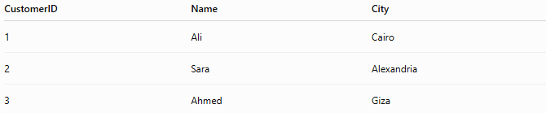
CustomerID | Name | City
1 | Ali | Cairo
2 | Sara | Alexandria
3 | Ahmed | Giza

SQL Statement
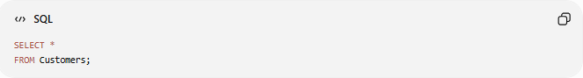
SELECT *
FROM Customers;

Result
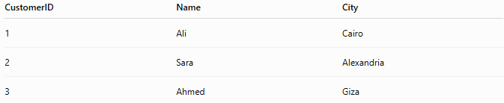
CustomerID | Name | City
1 | Ali | Cairo
2 | Sara | Alexandria
3 | Ahmed | Giza
SELECT * returns all columns and all rows.

📝 Basic Syntax
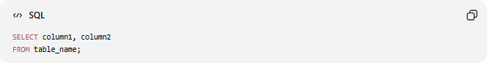
SELECT column1, column2
FROM table_name;

Syntax Breakdown
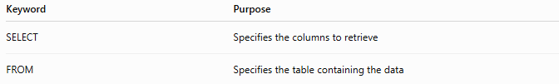
Keyword | Purpose
SELECT | Specifies the columns to retrieve
FROM | Specifies the table containing the data

📚 Example 1: Select Specific Columns
# Source: AI Source: Provided by: [Data Path: Persons Table -> ID Column: 1, Name_En Column: Motasem Essam] -> From: [ChatGPT] on [6/11/2026]
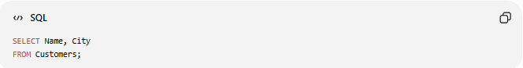
SELECT Name, City
FROM Customers;

Result
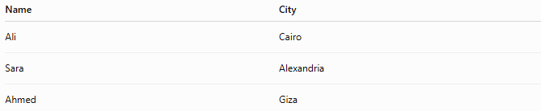
Name | City
Ali | Cairo
Sara | Alexandria
Ahmed | Giza
Only the selected columns are displayed.

📚 Example 2: Select All Columns
# Source: AI Source: Provided by: [Data Path: Persons Table -> ID Column: 1, Name_En Column: Motasem Essam] -> From: [ChatGPT] on [6/11/2026]
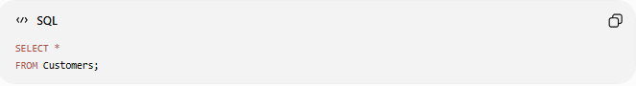
SELECT *
FROM Customers;

Result
Returns every column in the table.

📚 Example 3: Filter Data with WHERE
# Source: AI Source: Provided by: [Data Path: Persons Table -> ID Column: 1, Name_En Column: Motasem Essam] -> From: [ChatGPT] on [6/11/2026]
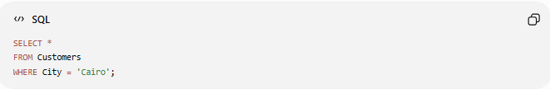
SELECT *
FROM Customers
WHERE City = 'Cairo';

Result
CustomerID | Name | City
1 | Ali | Cairo
Only customers from Cairo are returned.

📚 Example 4: Sort Data with ORDER BY
# Source: AI Source: Provided by: [Data Path: Persons Table -> ID Column: 1, Name_En Column: Motasem Essam] -> From: [ChatGPT] on [6/11/2026]
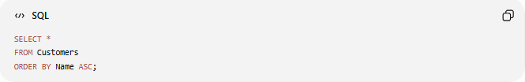
SELECT *
FROM Customers
ORDER BY Name ASC;

Result
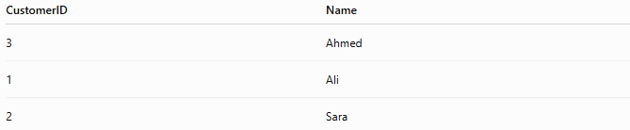
CustomerID | Name
3 | Ahmed
1 | Ali
2 | Sara
ASC sorts in ascending order.

Descending order:
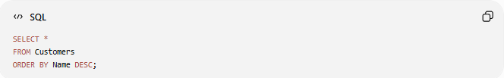
SELECT *
FROM Customers
ORDER BY Name DESC;

📚 Example 5: Limit the Number of Rows
# Source: AI Source: Provided by: [Data Path: Persons Table -> ID Column: 1, Name_En Column: Motasem Essam] -> From: [ChatGPT] on [6/11/2026]
(MySQL)
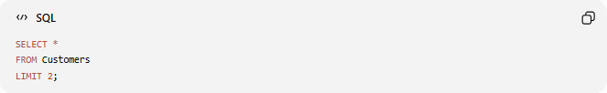
SELECT *
FROM Customers
LIMIT 2;

Result
Only the first two rows are returned.

📚 Example 6: Select Distinct Values
# Source: AI Source: Provided by: [Data Path: Persons Table -> ID Column: 1, Name_En Column: Motasem Essam] -> From: [ChatGPT] on [6/11/2026]
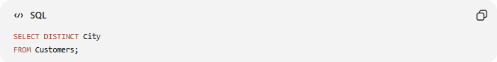
SELECT DISTINCT City
FROM Customers;

Suppose the Table Contains
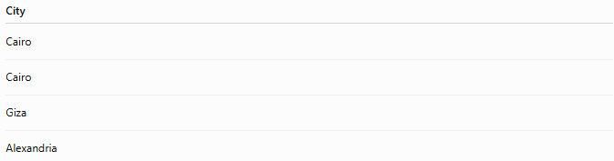
City
Cairo
Cairo
Giza
Alexandria

Result
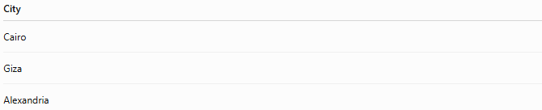
City
Cairo
Giza
Alexandria
Duplicate values are removed.

📚 Example 7: Using Multiple Conditions
# Source: AI Source: Provided by: [Data Path: Persons Table -> ID Column: 1, Name_En Column: Motasem Essam] -> From: [ChatGPT] on [6/11/2026]
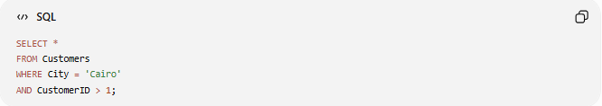
SELECT *
FROM Customers
WHERE City = 'Cairo'
AND CustomerID > 1;

Only rows satisfying both conditions are returned.

📚 Example 8: Search Using LIKE
# Source: AI Source: Provided by: [Data Path: Persons Table -> ID Column: 1, Name_En Column: Motasem Essam] -> From: [ChatGPT] on [6/11/2026]
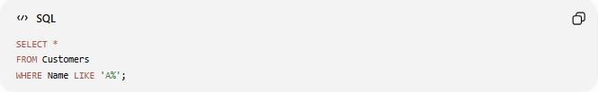
SELECT *
FROM Customers
WHERE Name LIKE 'A%';

Result
Name
Ali
Ahmed
Names beginning with A are returned.

📚 Example 9: Using Aliases
# Source: AI Source: Provided by: [Data Path: Persons Table -> ID Column: 1, Name_En Column: Motasem Essam] -> From: [ChatGPT] on [6/11/2026]
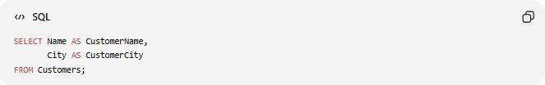
SELECT Name AS CustomerName,
City AS CustomerCity
FROM Customers;

Result
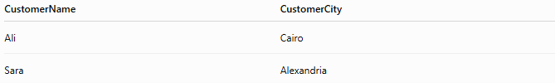
CustomerName | CustomerCity
Ali | Cairo
Sara | Alexandria
Aliases rename columns in the output.

📚 Example 10: Selecting from Multiple Tables
# Source: AI Source: Provided by: [Data Path: Persons Table -> ID Column: 1, Name_En Column: Motasem Essam] -> From: [ChatGPT] on [6/11/2026]
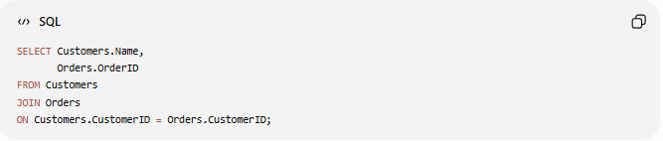
SELECT Customers.Name,
Orders.OrderID
FROM Customers
JOIN Orders
ON Customers.CustomerID = Orders.CustomerID;

Result
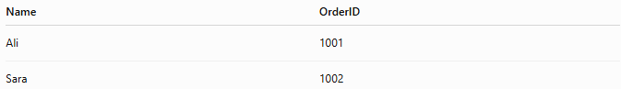
Name | OrderID
Ali | 1001
Sara | 1002

📚 Example 11: Select Top Rows (TOP)
# Source: AI Source: Provided by: [Data Path: Persons Table -> ID Column: 1, Name_En Column: Motasem Essam] -> From: [ChatGPT] on [6/11/2026]
The TOP clause is used to return only the first specified number of rows from a query result.
Note: TOP is supported by Microsoft SQL Server. In MySQL, use LIMIT instead.

Syntax (SQL Server)
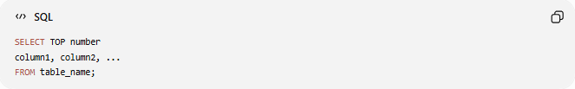
SELECT TOP number
column1, column2, ...
FROM table_name;

Example 1: Select the First 3 Employees
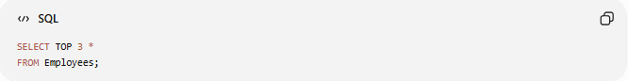
SELECT TOP 3 *
FROM Employees;
Result
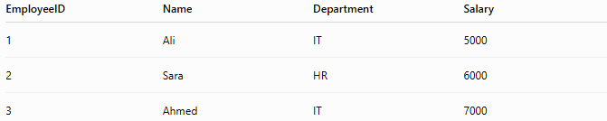
EmployeeID | Name | Department | Salary
1 | Ali | IT | 5000
2 | Sara | HR | 6000
3 | Ahmed | IT | 7000
Only the first 3 rows are returned.

Example 2: Select Top 2 Highest Salaries
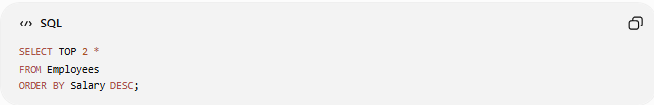
SELECT TOP 2 *
FROM Employees
ORDER BY Salary DESC;
Result
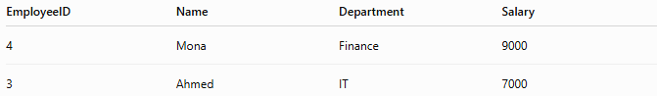
EmployeeID | Name | Department | Salary
4 | Mona | Finance | 9000
3 | Ahmed | IT | 7000
The rows are first sorted by Salary (highest to lowest), then only the top 2 are returned.

Example 3: Select Top 50 Percent of Rows (SQL Server)
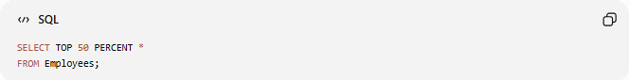
SELECT TOP 50 PERCENT *
FROM Employees;
Returns approximately the first 50% of the rows in the result set.

⚖️ TOP vs LIMIT vs FETCH FIRST
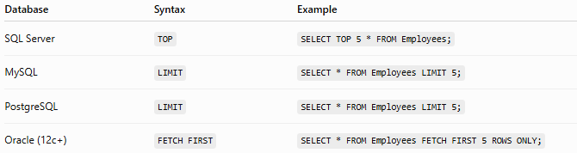
Database | Syntax | Example
SQL Server | TOP | SELECT TOP 5 * FROM Employees;
MySQL | LIMIT | SELECT * FROM Employees LIMIT 5;
PostgreSQL | LIMIT | SELECT * FROM Employees LIMIT 5;
Oracle (12c+) | FETCH FIRST | SELECT * FROM Employees FETCH FIRST 5 ROWS ONLY;

Tip: When using TOP, it's best to combine it with ORDER BY to ensure you get the specific "top" records you expect (such as the highest salaries or newest orders). Without ORDER BY, the database may return any first rows based on its execution plan.

📚 Example 12: OFFSET
# Source: AI Source: Provided by: [Data Path: Persons Table -> ID Column: 1, Name_En Column: Motasem Essam] -> From: [ChatGPT] on [6/11/2026]

The OFFSET clause is used to skip a specified number of rows before returning the remaining rows.
It is commonly used for:
- Pagination (Page 1, Page 2, Page 3...)
- Displaying search results
- Loading data in batches

📝 Syntax (SQL Server)
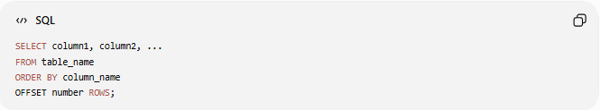
SELECT column1, column2, ...
FROM table_name
ORDER BY column_name
OFFSET number ROWS;
Note: In SQL Server, OFFSET must be used with an ORDER BY clause.

Example Table
Employees
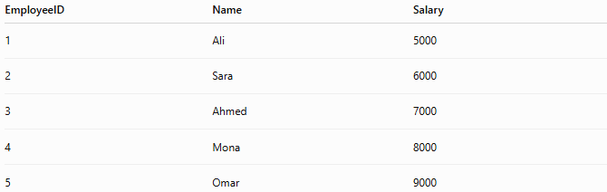
EmployeeID | Name | Salary
1 | Ali | 5000
2 | Sara | 6000
3 | Ahmed | 7000
4 | Mona | 8000
5 | Omar | 9000

Example 1: Skip the First 2 Rows
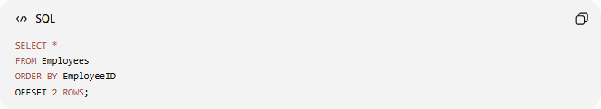
SELECT *
FROM Employees
ORDER BY EmployeeID
OFFSET 2 ROWS;
Result
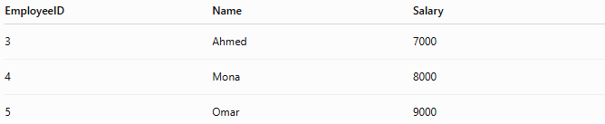
EmployeeID | Name | Salary
3 | Ahmed | 7000
4 | Mona | 8000
5 | Omar | 9000
The first 2 rows are skipped.

Example 2: Skip 3 Rows
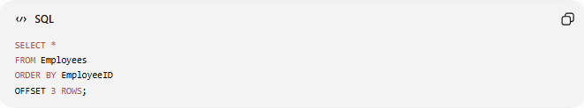
SELECT *
FROM Employees
ORDER BY EmployeeID
OFFSET 3 ROWS;
Result
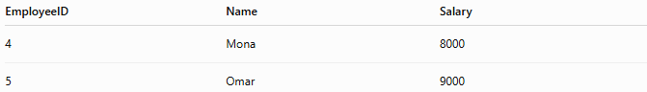
EmployeeID | Name | Salary
4 | Mona | 8000
5 | Omar | 9000

Example 3: Pagination (OFFSET + FETCH)
Display Page 2 with 2 records per page.
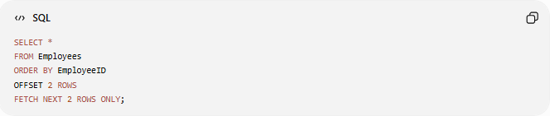
SELECT *
FROM Employees
ORDER BY EmployeeID
OFFSET 2 ROWS
FETCH NEXT 2 ROWS ONLY;
Result
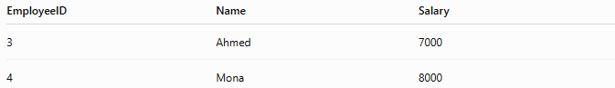
EmployeeID | Name | Salary
3 | Ahmed | 7000
4 | Mona | 8000
Explanation:
- Skip the first 2 rows.
- Return the next 2 rows.

Example 4: Page 3
Display the third page with 2 records per page.
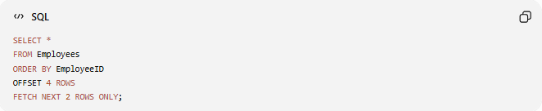
SELECT *
FROM Employees
ORDER BY EmployeeID
OFFSET 4 ROWS
FETCH NEXT 2 ROWS ONLY;
Result
EmployeeID | Name | Salary
5 | Omar | 9000
Only one row remains after skipping four rows.

📊 OFFSET vs TOP vs LIMIT
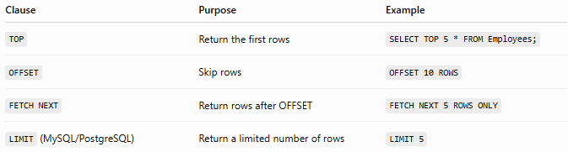
Clause | Purpose | Example
TOP | Return the first rows | SELECT TOP 5 * FROM Employees;
OFFSET | Skip rows | OFFSET 10 ROWS
FETCH NEXT | Return rows after OFFSET | FETCH NEXT 5 ROWS ONLY
LIMIT (MySQL/PostgreSQL) | Return a limited number of rows | LIMIT 5

🧭 Simple Summary
The OFFSET clause skips a specified number of rows before returning query results. It is commonly used with ORDER BY and often combined with FETCH NEXT in SQL Server to implement pagination, allowing applications to display data page by page.

📊 Common SELECT Clauses
# Source: AI Source: Provided by: [Data Path: Persons Table -> ID Column: 1, Name_En Column: Motasem Essam] -> From: [ChatGPT] on [6/11/2026]
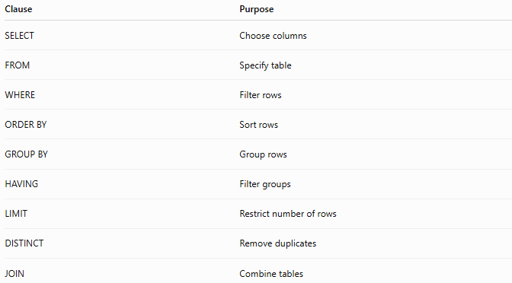
Clause | Purpose
SELECT | Choose columns
FROM | Specify table
WHERE | Filter rows
ORDER BY | Sort rows
GROUP BY | Group rows
HAVING | Filter groups
LIMIT | Restrict number of rows
DISTINCT | Remove duplicates
JOIN | Combine tables

📊 SELECT vs Other SQL Commands
# Source: AI Source: Provided by: [Data Path: Persons Table -> ID Column: 1, Name_En Column: Motasem Essam] -> From: [ChatGPT] on [6/11/2026]
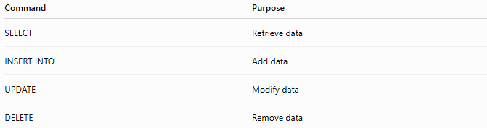
Command | Purpose
SELECT | Retrieve data
INSERT INTO | Add data
UPDATE | Modify data
DELETE | Remove data

🛠️ Complete Example
# Source: AI Source: Provided by: [Data Path: Persons Table -> ID Column: 1, Name_En Column: Motasem Essam] -> From: [ChatGPT] on [6/11/2026]
Create Table
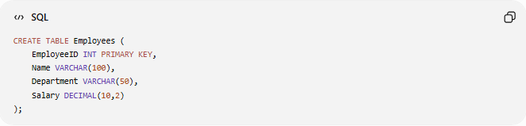
CREATE TABLE Employees (
EmployeeID INT PRIMARY KEY,
Name VARCHAR(100),
Department VARCHAR(50),
Salary DECIMAL(10,2)
);

Insert Data
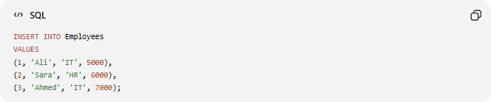
INSERT INTO Employees
VALUES
(1, 'Ali', 'IT', 5000),
(2, 'Sara', 'HR', 6000),
(3, 'Ahmed', 'IT', 7000);

Retrieve All Employees
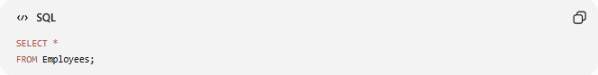
SELECT *
FROM Employees;

Retrieve Only IT Employees
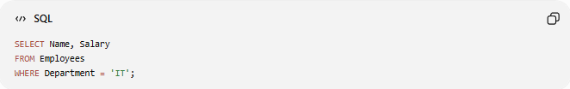
SELECT Name, Salary
FROM Employees
WHERE Department = 'IT';

Result
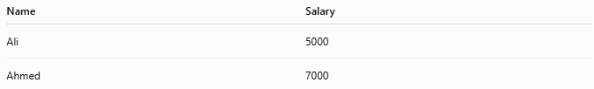
Name | Salary
Ali | 5000
Ahmed | 7000

⚠️ Common Errors
# Source: AI Source: Provided by: [Data Path: Persons Table -> ID Column: 1, Name_En Column: Motasem Essam] -> From: [ChatGPT] on [6/11/2026]
Wrong Table Name
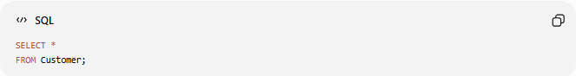
SELECT *
FROM Customer;
Error if the table is actually named Customers.

Wrong Column Name
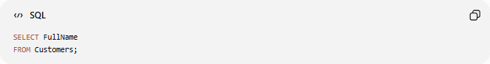
SELECT FullName
FROM Customers;
Error if FullName does not exist.

Missing FROM Clause
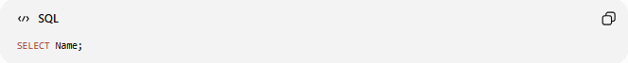
SELECT Name;
In most cases, a FROM clause is required to retrieve data from a table.

📊 Side-by-Side Comparison
# Source: AI Source: Provided by: [Data Path: Persons Table -> ID Column: 1, Name_En Column: Motasem Essam] -> From: [ChatGPT] on [6/11/2026]
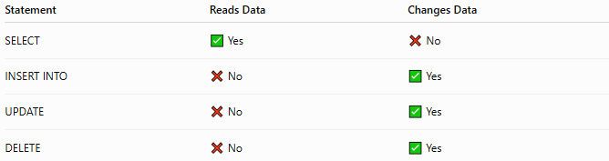
Statement | Reads Data | Changes Data
SELECT | ✅ Yes | ❌ No
INSERT INTO | ❌ No | ✅ Yes
UPDATE | ❌ No | ✅ Yes
DELETE | ❌ No | ✅ Yes

🧪 Complete Test Example

1️⃣ Create Table
# Source: AI Source: Provided by: [Data Path: Persons Table -> ID Column: 1, Name_En Column: Motasem Essam] -> From: [ChatGPT] on [6/11/2026]
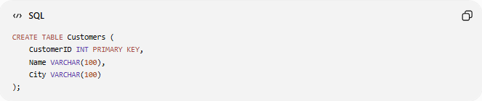
CREATE TABLE Customers (
CustomerID INT PRIMARY KEY,
Name VARCHAR(100),
City VARCHAR(100)
);

2️⃣ Insert Sample Data
# Source: AI Source: Provided by: [Data Path: Persons Table -> ID Column: 1, Name_En Column: Motasem Essam] -> From: [ChatGPT] on [6/11/2026]
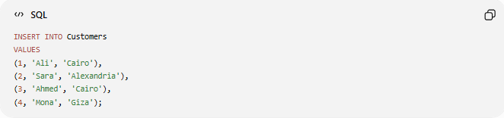
INSERT INTO Customers
VALUES
(1, 'Ali', 'Cairo'),
(2, 'Sara', 'Alexandria'),
(3, 'Ahmed', 'Cairo'),
(4, 'Mona', 'Giza');

3️⃣ View All Records
# Source: AI Source: Provided by: [Data Path: Persons Table -> ID Column: 1, Name_En Column: Motasem Essam] -> From: [ChatGPT] on [6/11/2026]
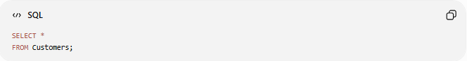
SELECT *
FROM Customers;

4️⃣ Select Specific Columns
# Source: AI Source: Provided by: [Data Path: Persons Table -> ID Column: 1, Name_En Column: Motasem Essam] -> From: [ChatGPT] on [6/11/2026]
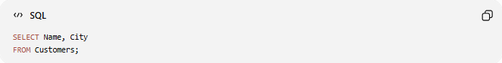
SELECT Name, City
FROM Customers;

5️⃣ Filter by City
# Source: AI Source: Provided by: [Data Path: Persons Table -> ID Column: 1, Name_En Column: Motasem Essam] -> From: [ChatGPT] on [6/11/2026]
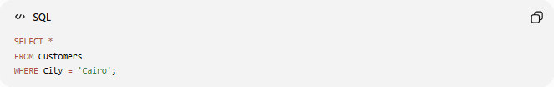
SELECT *
FROM Customers
WHERE City = 'Cairo';

6️⃣ Sort by Name
# Source: AI Source: Provided by: [Data Path: Persons Table -> ID Column: 1, Name_En Column: Motasem Essam] -> From: [ChatGPT] on [6/11/2026]
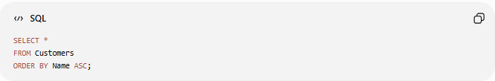
SELECT *
FROM Customers
ORDER BY Name ASC;

7️⃣ Show Unique Cities
# Source: AI Source: Provided by: [Data Path: Persons Table -> ID Column: 1, Name_En Column: Motasem Essam] -> From: [ChatGPT] on [6/11/2026]
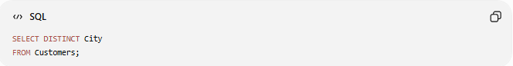
SELECT DISTINCT City
FROM Customers;

Real Example

prepared commands

1️⃣ Create Table
# Source: ScreenShot Source: Provided by: [Persons Table -> ID Column: 1, Name_En Column: Motasem Essam] -> Tool: [Automation Table -> ID Column: 16, Name_En Column: Screen Capture] -> From [Operating System: Wampserver64 -> phpmyadmin] on [6/11/2026]
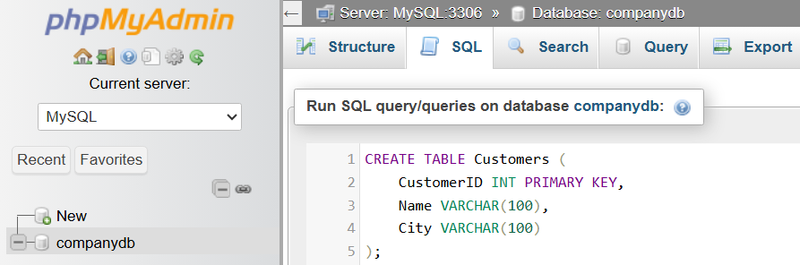
CREATE TABLE Customers (
CustomerID INT PRIMARY KEY,
Name VARCHAR(100),
City VARCHAR(100)
);
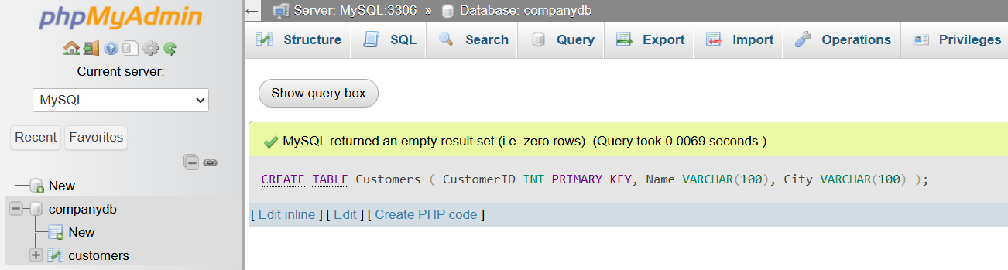

2️⃣ Insert Sample Data
# Source: ScreenShot Source: Provided by: [Persons Table -> ID Column: 1, Name_En Column: Motasem Essam] -> Tool: [Automation Table -> ID Column: 16, Name_En Column: Screen Capture] -> From [Operating System: Wampserver64 -> phpmyadmin] on [6/11/2026]
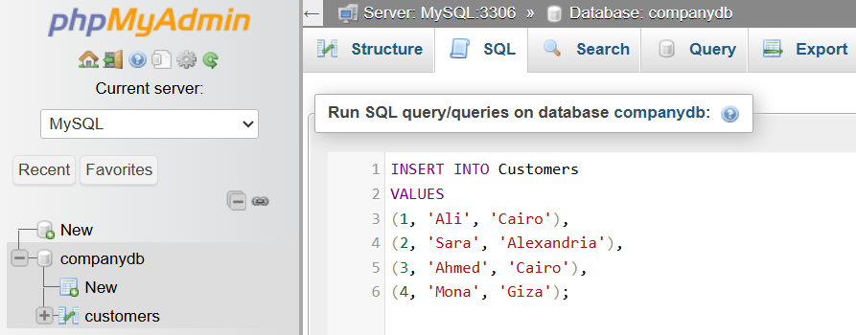
INSERT INTO Customers
VALUES
(1, 'Ali', 'Cairo'),
(2, 'Sara', 'Alexandria'),
(3, 'Ahmed', 'Cairo'),
(4, 'Mona', 'Giza');
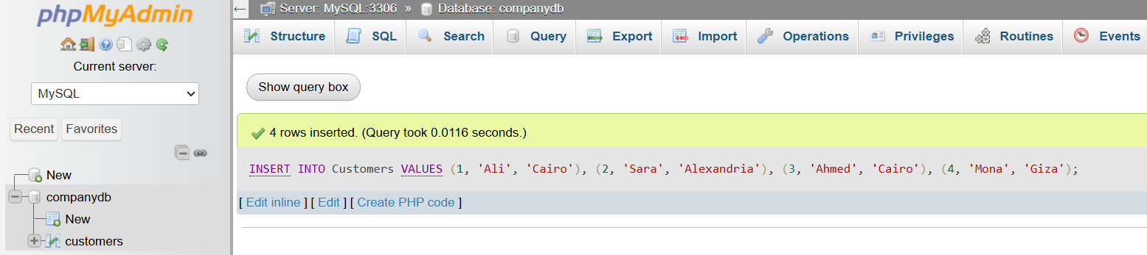

basic command

3️⃣ View All Records
# Source: ScreenShot Source: Provided by: [Persons Table -> ID Column: 1, Name_En Column: Motasem Essam] -> Tool: [Automation Table -> ID Column: 16, Name_En Column: Screen Capture] -> From [Operating System: Wampserver64 -> phpmyadmin] on [6/11/2026]
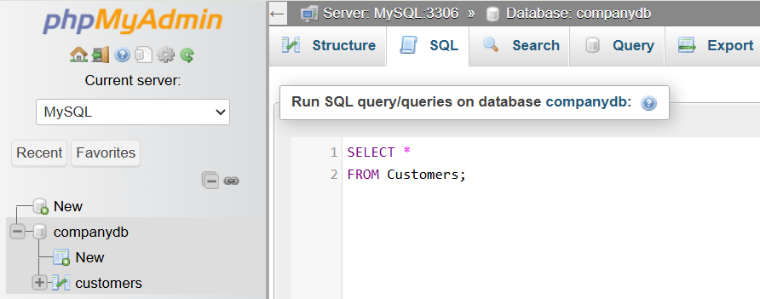
SELECT *
FROM Customers;
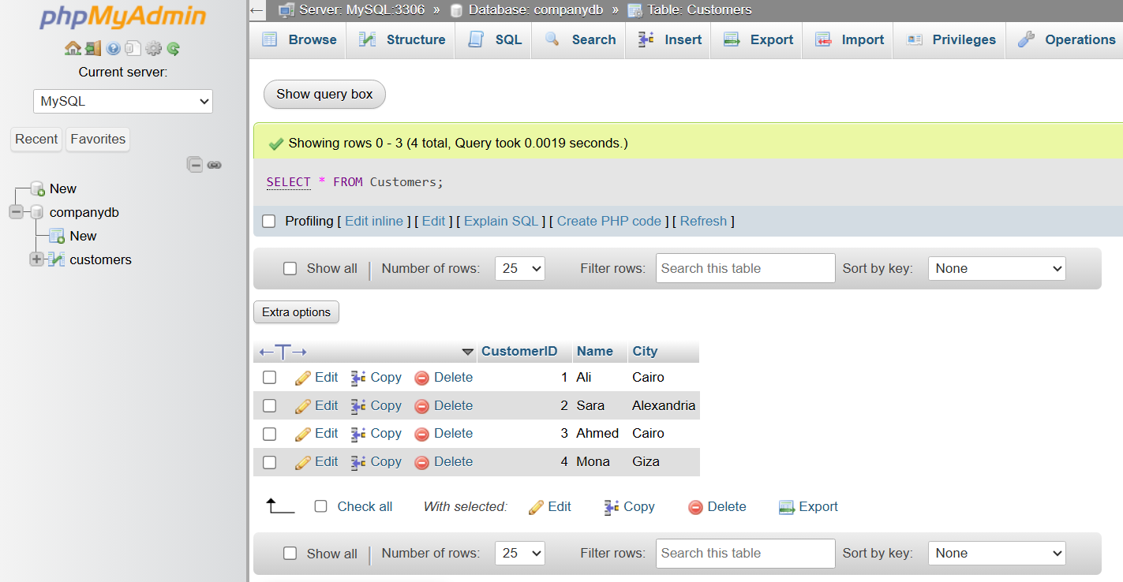

4️⃣ Select Specific Columns
# Source: ScreenShot Source: Provided by: [Persons Table -> ID Column: 1, Name_En Column: Motasem Essam] -> Tool: [Automation Table -> ID Column: 16, Name_En Column: Screen Capture] -> From [Operating System: Wampserver64 -> phpmyadmin] on [6/11/2026]
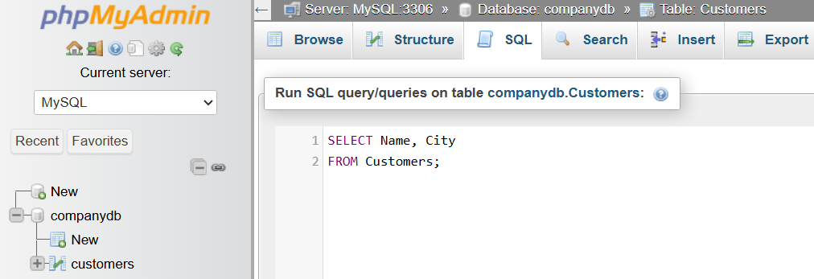
SELECT Name, City
FROM Customers;
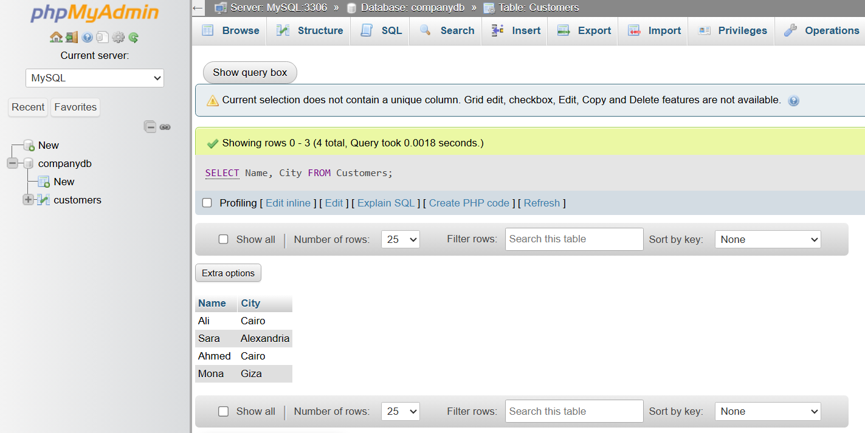

5️⃣ Filter by City
# Source: ScreenShot Source: Provided by: [Persons Table -> ID Column: 1, Name_En Column: Motasem Essam] -> Tool: [Automation Table -> ID Column: 16, Name_En Column: Screen Capture] -> From [Operating System: Wampserver64 -> phpmyadmin] on [6/11/2026]
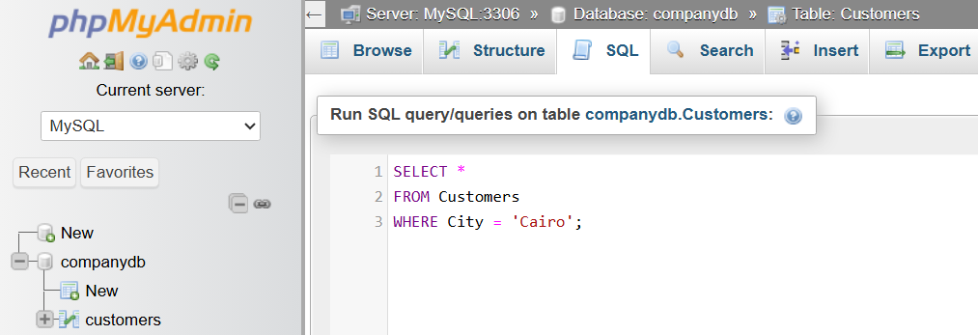
SELECT *
FROM Customers
WHERE City = 'Cairo';
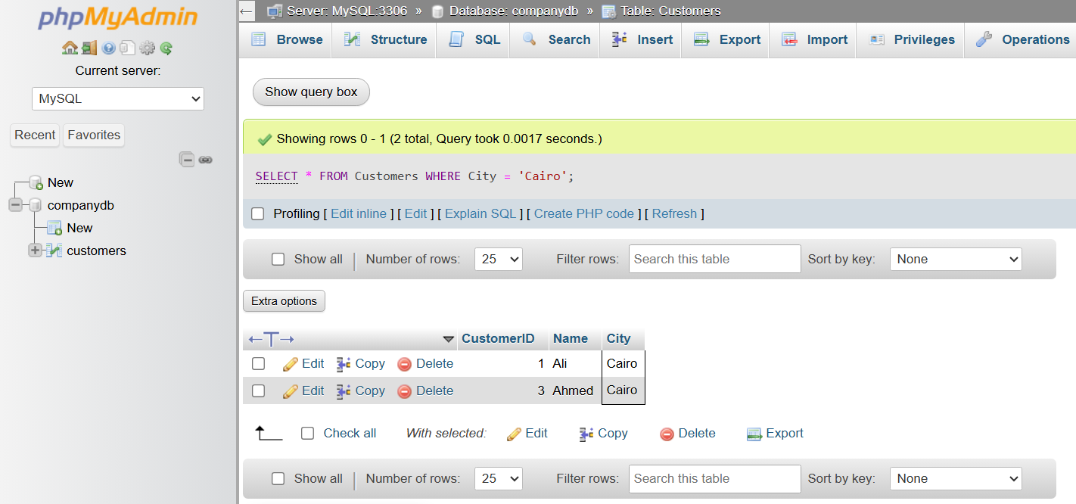

6️⃣ Sort by Name
# Source: ScreenShot Source: Provided by: [Persons Table -> ID Column: 1, Name_En Column: Motasem Essam] -> Tool: [Automation Table -> ID Column: 16, Name_En Column: Screen Capture] -> From [Operating System: Wampserver64 -> phpmyadmin] on [6/11/2026]
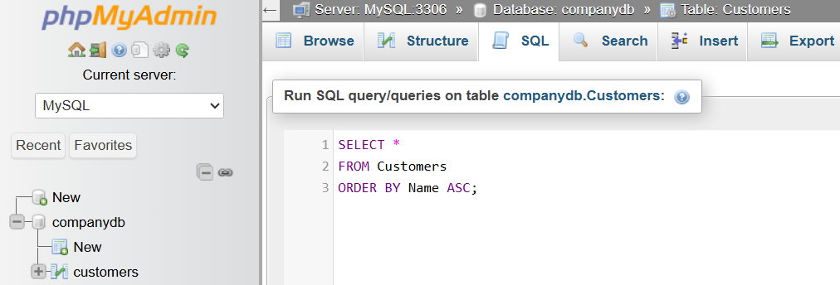
SELECT *
FROM Customers
ORDER BY Name ASC;
SELECT *
FROM Customers
ORDER BY Name ASC;

7️⃣ Show Unique Cities
# Source: ScreenShot Source: Provided by: [Persons Table -> ID Column: 1, Name_En Column: Motasem Essam] -> Tool: [Automation Table -> ID Column: 16, Name_En Column: Screen Capture] -> From [Operating System: Wampserver64 -> phpmyadmin] on [6/11/2026]
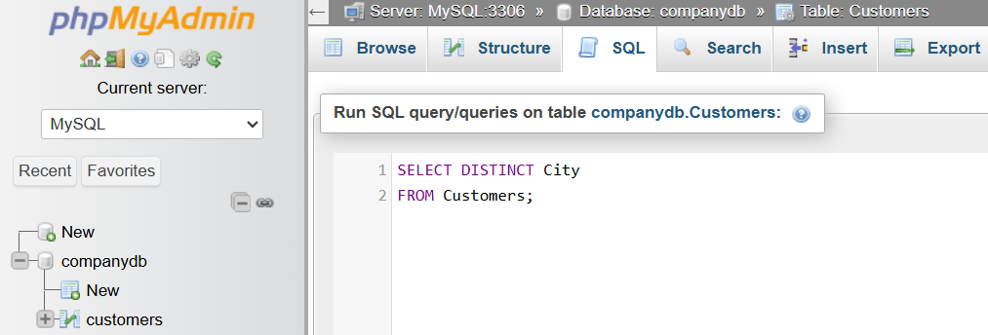
SELECT DISTINCT City
FROM Customers;
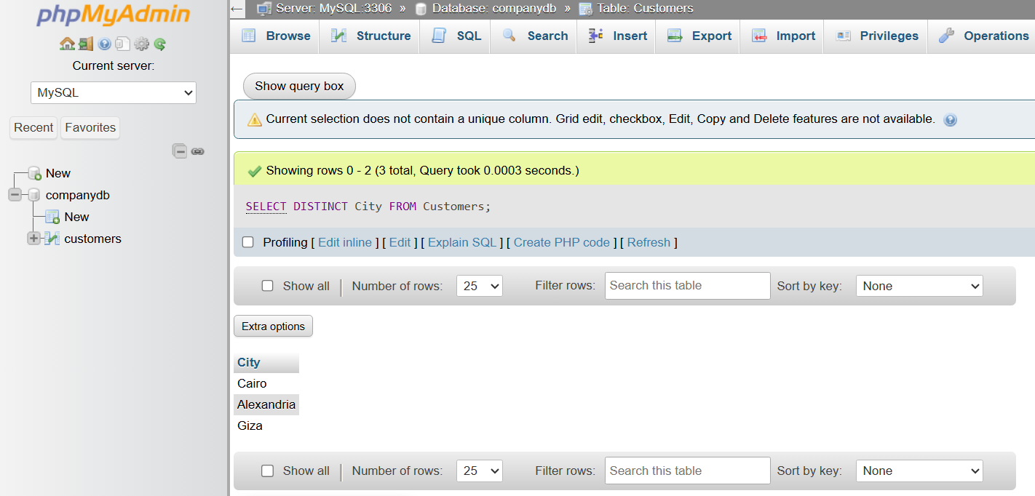

🔢 SELECT Workflow
# Source: AI Source: Provided by: [Data Path: Persons Table -> ID Column: 1, Name_En Column: Motasem Essam] -> From: [ChatGPT] on [6/11/2026]
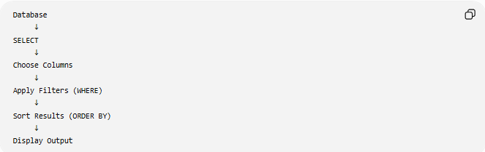
Database
↓
SELECT
↓
Choose Columns
↓
Apply Filters (WHERE)
↓
Sort Results (ORDER BY)
↓
Display Output

🧠 Simple Analogy
# Source: AI Source: Provided by: [Data Path: Persons Table -> ID Column: 1, Name_En Column: Motasem Essam] -> From: [ChatGPT] on [6/11/2026]
Imagine a large filing cabinet.
- SELECT is like opening the cabinet and reading files.
- INSERT adds a new file.
- UPDATE edits an existing file.
- DELETE removes a file.
With SELECT, you only view the information—you do not change it.

🧭 Summary
# Source: AI Source: Provided by: [Data Path: Persons Table -> ID Column: 1, Name_En Column: Motasem Essam] -> From: [ChatGPT] on [6/11/2026]
SQL SELECT is the primary Data Query Language (DQL) statement used to retrieve data from one or more database tables. It can return all columns or selected columns, filter rows with WHERE, sort results using ORDER BY, remove duplicates with DISTINCT, limit returned rows with LIMIT, and combine data from multiple tables using JOIN. It is the foundation of querying and reporting in SQL.

